Request for Decision – User Interface for OKTA and Client Applications
Architecture Decision

Digital Program
IS/Security/Architecture
June 8, 2020

Ver. No. | Description | Updated By | Date
01 | Document UI options needed to integrate Okta and the Digital Banking platform | Roney Simon Mathews | May 26, 2020
02 | Design options and document Pros and Cons | Vikram Singh | June 3, 2020
03 | Review and provide feedback | Reinhardt Tonn | June 8, 2020
04 | Finalized document | Vikram Singh | June 8, 2020

Contents
Topic 3
Background 3
Guiding Principles 4
Assumptions and Key Requirements 4
Alternatives 4
Alternative 1: Client Application Integrates with Okta APIs 5
Alternative 2: Client Application Redirects to Okta 7
Alternative 3: Client Application Embeds Okta Widget 9
Alternative 4: Client Application Redirects to Universal Login Application 11
Recommendation/Rationale 13
Analysis 13
Implications 15
Attachments 15
Decision 15
Prepared by: 15
Reviewed by: 15
Approved by: 15

Request For Decision
Purpose: This document will be used by the IAM Project to determine the best method to ensure a positive customer login experience.
Program Name | Identity and Access Management
Project Stream / Business Area | Client (CIAM) login experience
RFD Presented to: | Technical Review Board, Digital Project team

Topic
CWBFG’s Okta Identity and Access Management service will be embedded directly in the client application platform, safeguarding the apps, and strengthening security posture. Leveraging this service will allow the application developers to focus on innovation, brand differentiators, and an enhanced, intuitive user experience.
This Request for Decision document will present the alternatives that have been considered to integrate Okta – Customer Identity and Access Management service (herein referred to as CIAM) with the CWBFG client web applications.

Background
At present, depending on the customer application platform (Small business, Personal or Commercial), different identity stores and authorization methods have been adopted for example in online banking application, some are stored in T24 Banking system and some in the Central 1 platform. We are required to streamline the identity and access management experience to a single platform to improve user experience and security controls.
With Okta and client applications integrated together, CWBFG can quickly build web and mobile applications, or enhance existing applications, and do so backed by world-class identity security. Existing CWB users and new user accounts (created for the differnt Client Onboarding platforms) will be required to authenticate to access the application platform using secure customer identity and state-of-the-art authentication technology.

Guiding Principles
- GAP02: Seek Architecture Approval
  - Seek architecture inputs and approval at key project gates throughout the project governance and delivery lifecycle
- IMP06: Data Integration
  - Integration design should be driven by business needs, and leverage industry standards when available. Where appropriate, real-time integration is preferred over batch integration, and data replication.
- APP07: Applications Expose Data
  - All Commercial Off-the-Shelf (COTS) or in-house developed applications should have the ability to expose data using industry standards-based mechanisms and formats to enable integration, and allow internal and public consumption without compromising security.
- TEP04: Standards of Interoperability and Scalability
  - Software solutions and hardware platforms and development processes should conform to industry standards and best practices that promote interoperability for data, applications, and technology to
Enable incremental scaling (up, out) of resources to control cost as maximize ROI.
- BUP03: Reuse before buy, Buy before build, Configure before Customizing
  - Technology solutions, business applications, system components and data will be reused wherever possible, purchased or acquired (Open Source) if necessary, and only built if there is a unique requirement that cannot otherwise be fulfilled.

Assumptions and Key Requirements
- Dependency on the Okta CIAM solution to provide a digital layer that can be embedded within our digital banking web portals.
- Kony’s Next Generation Digital Banking platform will be used to deliver seamless and enhanced experiences to CWB customers with the various banking services and channels.
- Multiple protocols/standards must be supported for digital experiences, including OIDC and SAML.
- CWB provide a SSO(Single Sign-On) experience between CWBFG customer-facing applications.
- The authentication experience is brandable across CWBFG lines of business/affiliates.
- Authentication, self-service and step-up challenge flows, factors and policies are centralized and readily changeable to incorporate class-leading authentication capabilities across CWBFG properties.

Alternatives
- Client Application Integrates with Okta APIs
- Client Application Redirects to Okta
- Client Application Embeds Okta Widget
- Client Application Redirects to Universal Login Application

Alternative 1: Client Application Integrates with Okta APIs

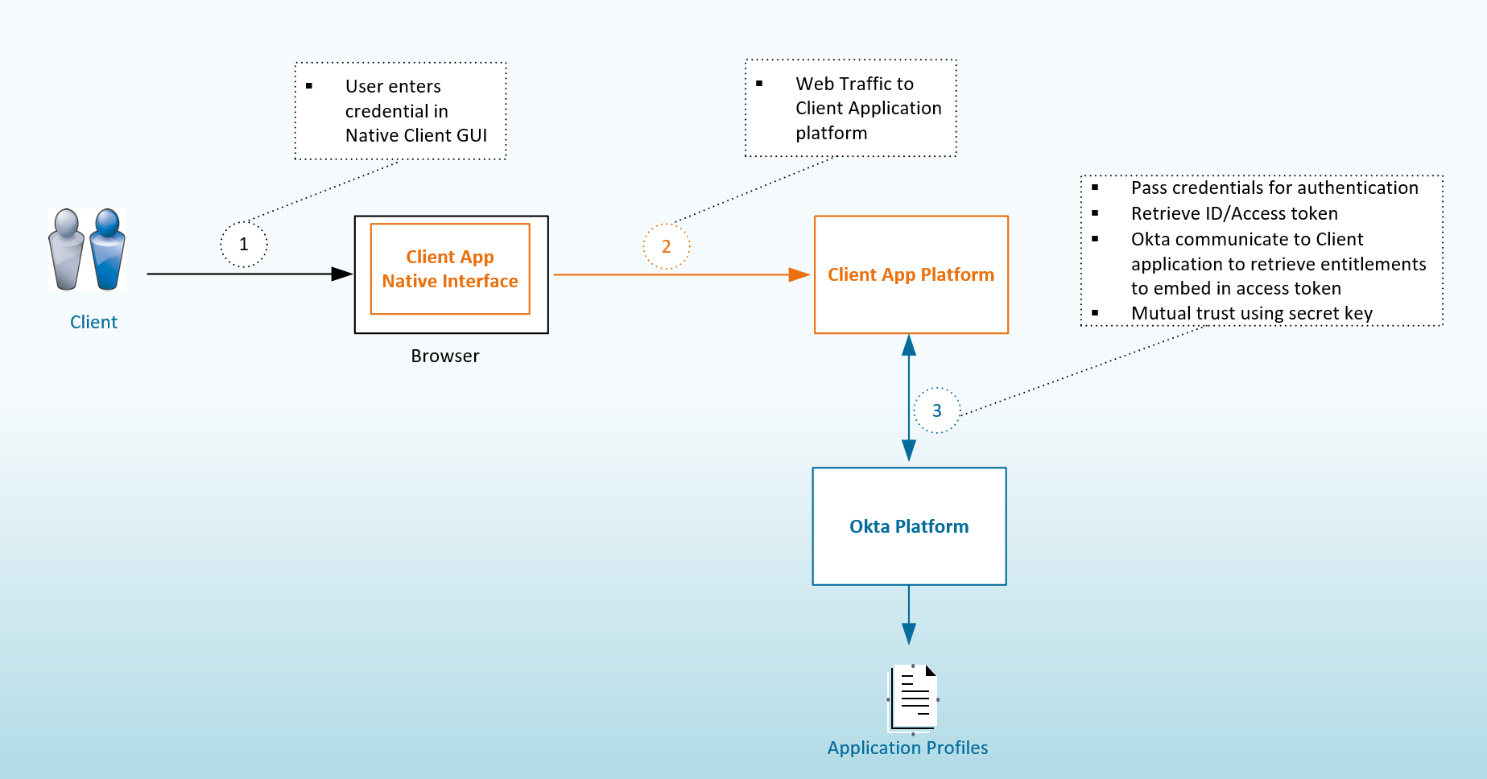

Pros:
- Client application native out-of-the-box authentication user interface and user experience is utilized. API calls from client platform to Okta are secured through TLS and the IAM integration is transparent to the end user.
- The Customer is unaware of the specific IAM technology platform used in background. This reduces the security exposure of the IAM platform by not exposing IAM via public interfaces/integration points.
- The user experience will not be impacted by technology changes due to upgrades/updates or the replacement of the IAM system. Development will absorb the changes if any from technology perspective.
- Performance will increase by using native platform functionality which has tight integrations with other product modules
- Consuming applications can provide a native and seamless experience for both desktop and mobile experiences.
- If necessary, Okta can be replaced by a different solution without impacts to the user authentication experiences.
- Digital Project specific: Alternative 1 is the proved option on Kony and several of their clients currently use this approach
Cons:
- The consuming application (e.g. Kony, Digital Client Onboarding, etc) is responsible for the security of the authentication experience.
- CWBFG applications will not be able to leverage the Okta Single Sign-On capabilities. As per Kony, they can probably use the ID token to provide the Single Sign On capablilities, provided they can call the /authorize endpoint and the user is trying to single sign on from the application that they authenticated on(Example: Kony)
- Each CWBFG application will own its own native login experience. Changes to the login sequence, the introduction of new authentication factors, changes to adaptive authentication rules/policy will all require development changes to each application. This does not support the ESA goal of one centralized IAM service.
- The consuming application is aware of the user’s credentials and could potentially store these outside of IAM Platform. As per Kony, they keep the username stored on the DBX database.
- As per Okta, There may be application interface latency introduced by network traffic to call Okta APIs for every authentication attempt.

Alternative 2: Client Application Redirects to Okta
The Client application is redirected to the Okta platform for authentication using the OpenID Connect standard . OpenID Connect is an identity layer on top of the OAuth, which allows Clients to verify the identity of the End-User based on the authentication performed by the Authorization Server and obtain basic profile information in a REST-like manner utilizing a secure token (ID token) that contains a new set of identity scopes and claims.
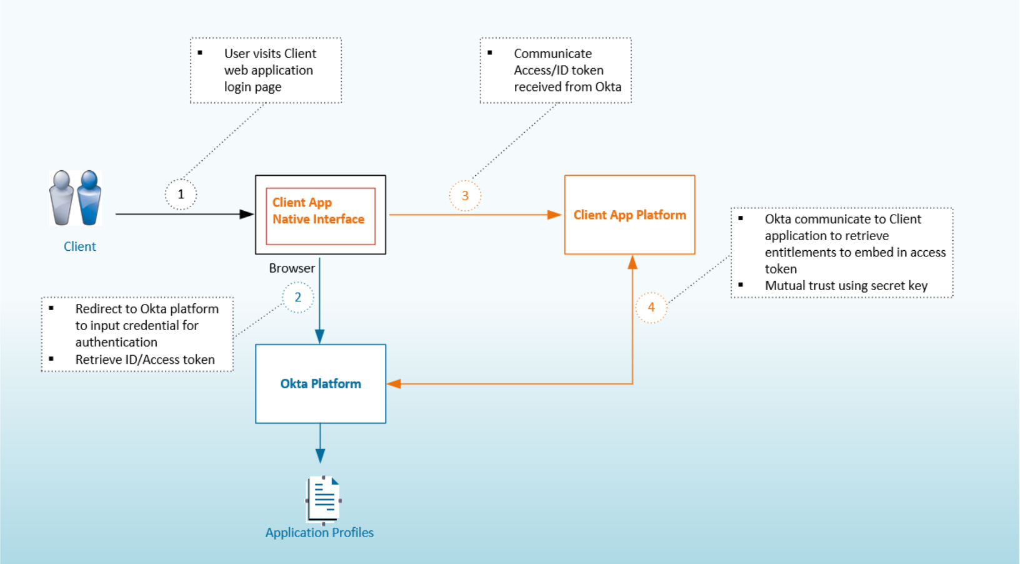
Pros:
- The application team concentrates on core functionality and relies on the IAM platform to provide a secure authentication experience, maximizing reuse of a common asset
- This scenario will assist in aligning with modern industry standards supported by Kony and other modern applications
- Standards-based integration based on OIDC and SAML would allow for the replacement of the IAM component with relatively little development effort.
- This alternate will present a consistent authentication experience for all Customer applications.
Cons:
- Client applications must adopt OIDC. If this is not natively supported, then there is a need for additional development effort to adopt the standard.
- The IAM Platform is exposed directly to the end user which can be exploited (Known vulnerability or zero day authentication protocol level bug) by malicious users to gain access to CWBFG applications. Saying that risk is considered low as an industry leader in identity management, it’s large exposure through it’s customer base, and ongoing audit and compliance certifications, Okta focuses on a more secure platform than custom or open source applications.
- Available application profile information in Okta might give a malicious user access to other applications with SSO capabilities
- Education and training requirements are key component and must be considered as users might take re-direction to another site as a security problem and report false positive events.
- Digital Project specific: As per Kony, Alternative 2 would require a POC

Alternative 3: Client Application Embeds Okta Widget

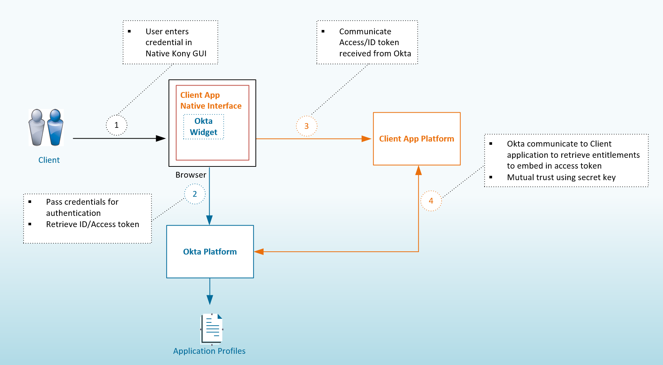

Pros:
- The user experience can be customized within the native application platform, providing benefits of both option 1 and 2
- The Okta widget is fully customizable when hosted with the Client application.
- All IAM API integration and OIDC protocol support is transparent to the Client application.
- The availability and performance of the authentication UI is not dependent on an additional application. However, the solution remains dependent on Okta’s availability.
Cons:
- Native mobile applications leverage a browser based authentication experience, as per OIDC best practices. This may have some user experience implications.
- Additional development effort required to customize the Okta Widget building and installation, Mobile considerations and support.
- Widgets use JavaScript platform which has known security issues (cross site scripting XSS, cross site request forgery CSRF, server side script injection etc.) if not developed/maintained according to defined industry standards. This is deemed low risk as Okta’s widget is a commercial and highly verified javascript solution.
- Digital Project specific: From Kony’s perspective Alternative 3 is implemented with 1 customer and might need a POC.

Alternative 4: Client Application Redirects to Universal Login Application

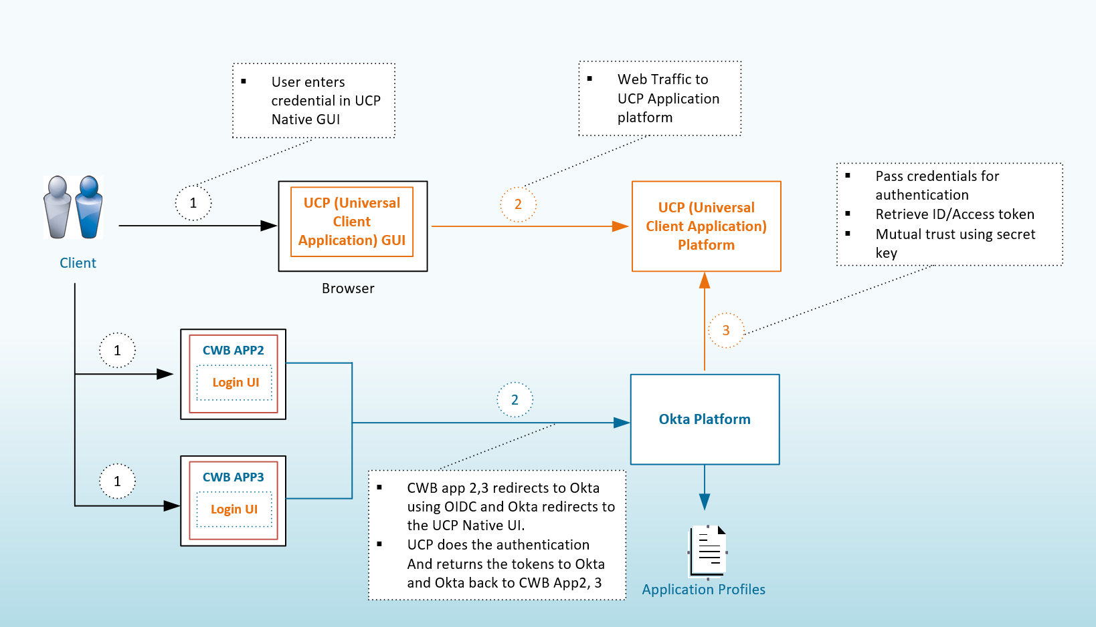

Pros:
- Replicate single user experience to all CWBFG customer applications for unique branding
- Security controls and application development concentrated to single login platform as compared to point solutions for every application native experience.
- Increases customer confidence with awareness of CWBFG branded sites and making it easier to detect phishing websites.
- Development effort for a common user authentication experience is based on a platform CWB has licenced that will provide all of Digital Banking.
- If necessary, Okta can be replaced by a different solution without impacts to the user authentication experiences.
Cons:
- Additional design, development and maintainence effort required in Kony to provide a branded experience for all customer facing CWBFG applications.
- The Universal Login Application will be required to provide world class security to prevent single point of failure or compromise in addition to Increased complexity of the overall identity solution.
- The Universal Login Application must be able to support the SLAs of all customer facing CWBFG applications.
- Digital Project specific: As per Kony, Alternative 2 would require a POC

-

Recommendation/Rationale

Analysis
1=High Risk/Effort , 2 = Medium Risk/Effort, 3= Low Risk/Effort
Criteria | Description | Option1 | Option2 | Option3 | Option4
01 | Development effort – Identify the sequence of activities that need to be performed for the project to be completed. Combine effort estimates of tasks of activity to produce an estimate for developing interface and API integrations | 2 | 2 | 3 | 1
02 | User experience Impact – overall experience of a person using an online banking application, especially in terms of how easy or pleasing it is to use. | 3 | 2 | 3 | 2
03 | Future enhancements - undetermined events that will occur in future and likelihood of later improvement or advancement. | 1 | 3 | 3 | 2
04 | Security Impact - determine the extent to which changes to the information system have affected the security state of the system | 1 | 3 | 3 | 2
05 | Training/education requirement - learning to login and absorb different scenarios such as MFA, Adaptive login, URL redirection | 3 | 2 | 3 | 2
06 | Mobile Experience - mobile product or service exposing positive user experience strategy include customer-driven design, rapid prototyping and usability evaluations. | 3 | 2 | 2 | 2
07 | Customization - modification made to digital banking or IAM platform to suit a specific purpose such as Open Banking, Secure key concierge. | 2 | 2 | 3 | 2
08 | Supports Key Requirements – SSO, Standard Protocol Support, Brandable pages. | 1 | 3 | 3 | 3
 | Total Score | 16 | 19 | 23 | 16

Implications
N/A

Attachments
N/A

Decision

Prepared by:
Name:

Reviewed by:
Name: TRB

Approved by:

Name: ASRB

